Artificial Intelligence in Everyday Life: An Ethical and Societal Analysis of ChatGPT

Introduction
Artificial intelligence has become part of my everyday life. I use AI to brainstorm ideas, explain difficult topics, organize information, improve writing, and solve problems faster. Because I use tools like ChatGPT so often, I wanted to better understand both the incredible opportunities they create and the ethical responsibilities that come with them. ChatGPT is one of the best-known examples of generative AI, and it has changed how students, businesses, programmers, and professionals work.

1. Overview of the AI System
ChatGPT is a generative AI system built on a large language model. Instead of searching for answers like a traditional search engine, it predicts the most likely sequence of words based on patterns learned from enormous amounts of text. People use it for writing, coding, tutoring, brainstorming, translation, customer service, and research assistance. Businesses use similar technology to improve productivity and automate repetitive tasks.
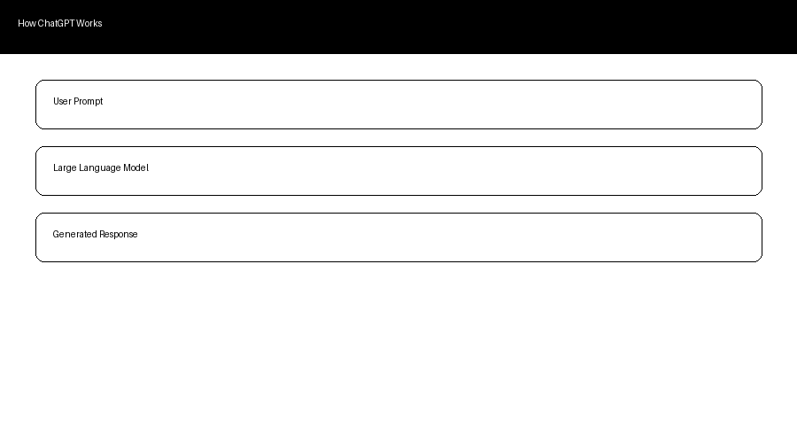
Figure 1. Simplified workflow of a generative AI system.

2. Benefits and Positive Impact
Generative AI improves productivity by helping users complete tasks much faster. Students receive tutoring and explanations, programmers debug code, businesses automate customer support, and healthcare workers reduce paperwork. AI also improves accessibility by translating languages, simplifying technical concepts, and helping people with disabilities communicate more effectively. Rather than replacing creativity, I often find AI helps me organize ideas so I can produce better work.

3. Ethical Issues
Despite its benefits, AI raises serious ethical questions. Bias can appear when training data reflects historical inequalities. Privacy is another concern because AI systems rely on enormous amounts of information, making responsible data protection essential. Transparency also matters because users deserve to understand AI limitations. Hallucinations, misinformation, copyright concerns, and deepfakes demonstrate why human judgment remains necessary.

4. Societal Implications
AI is changing education, business, healthcare, software development, and customer service. Some repetitive jobs may become automated, but entirely new careers are emerging in AI engineering, cybersecurity, prompt engineering, and governance. Society must improve AI literacy so people understand both the strengths and limitations of these tools.

5. Risks and Challenges
Major risks include misinformation, phishing attacks, cybercrime, overreliance on AI, inaccurate answers, and evolving legal questions. Organizations should never rely exclusively on AI for decisions involving healthcare, finance, or law without human review.

6. Recommendations
Governments should create balanced regulations that encourage innovation while protecting privacy. Developers should improve transparency, reduce bias, and clearly communicate model limitations. Schools should teach AI literacy, and organizations should establish policies requiring human oversight for high-impact decisions.
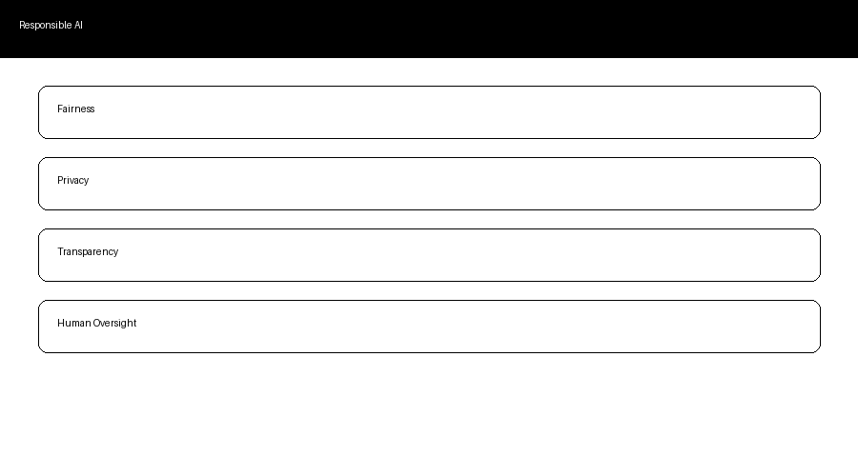
Figure 2. Core principles of responsible AI.

Conclusion
Researching this topic reinforced why I enjoy using AI every day. ChatGPT has become one of my favorite tools because it helps me learn faster, solve problems, and become more productive. However, the more powerful AI becomes, the more important it is to develop and use it responsibly. I believe AI should enhance human abilities rather than replace human judgment, and with thoughtful regulation and ethical design, it can improve life across nearly every industry.

References
OpenAI. ChatGPT.
NIST AI Risk Management Framework (2023).
UNESCO Recommendation on the Ethics of Artificial Intelligence (2021).
European Union AI Act (2024).
Russell & Norvig. Artificial Intelligence: A Modern Approach (2021).

